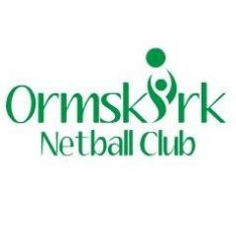

**Financial Policy**

Ormskirk Netball Club policy is:

The first session (taster session) is free!

Then 10 weeks advance payment must be made from the date your child joins the club.

The cost is £6 per 90-minute session, there is one session per week, which means it is £60 every 10 weeks.

If you have more than 1 child at our club, a 5% discount is awarded.

No refunds can be made for missed sessions.

Refunds will only be made when the club has to cancel sessions.